Collections

Q-1. Write Java code to define List . Insert 5 floating point numbers in List, and using an iterator, find the sum of the numbers in List.

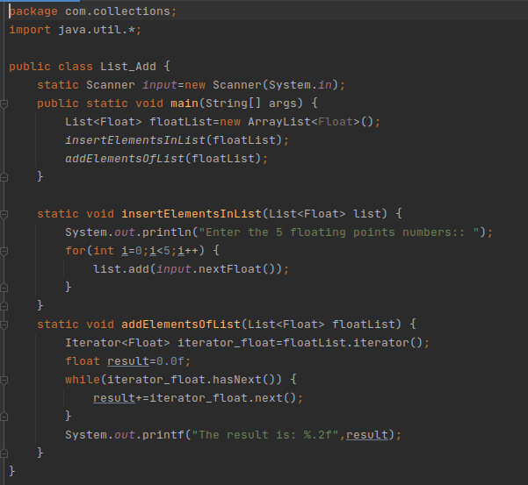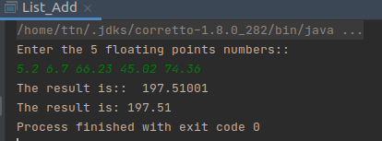

Q-2. Write a method that takes a string and returns the number of unique characters in the string.

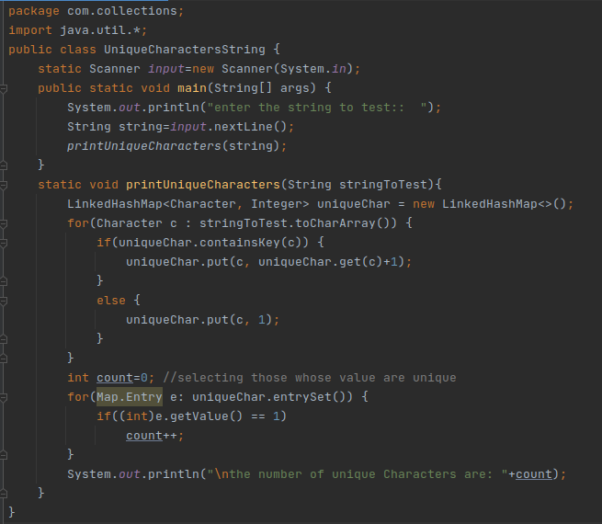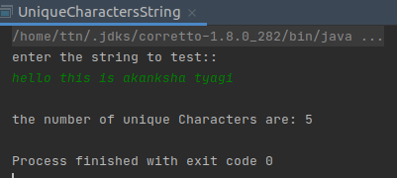

Q-3. Write a method that takes a string and prints the number of occurrences of each character in the string.

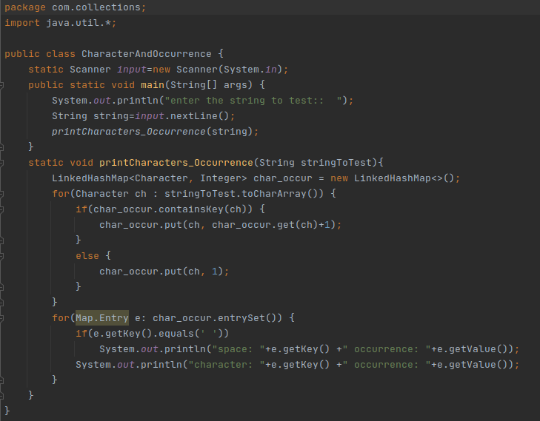

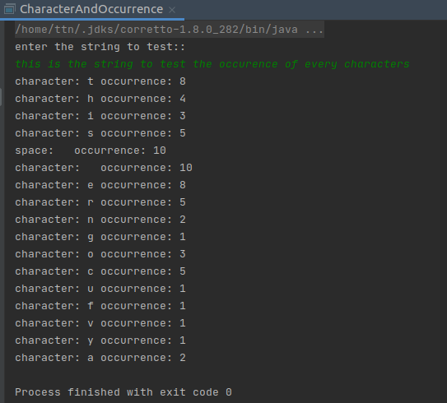

Q-4. Write a program to sort Employee objects based on highest salary using Comparator. Employee class{ Double Age; Double Salary; String Name.

**employee.java**

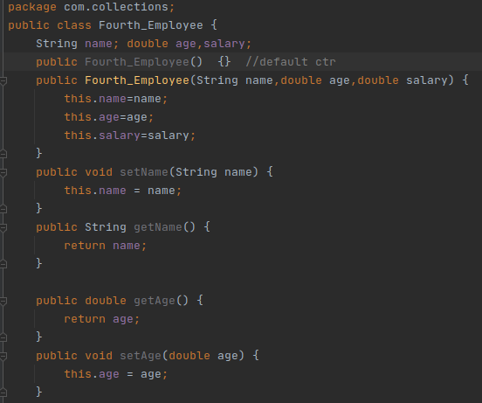



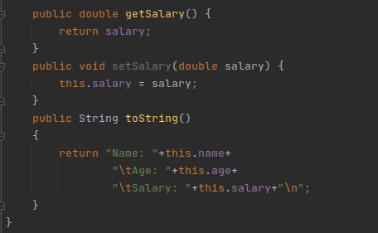

**salaryComparator.java:**

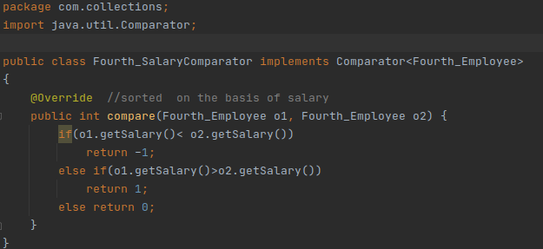

EmployeeMaine.java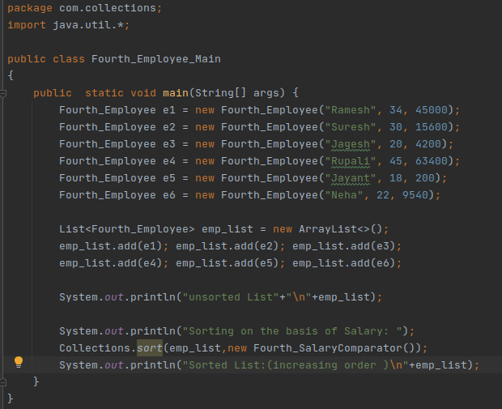

**Output:**

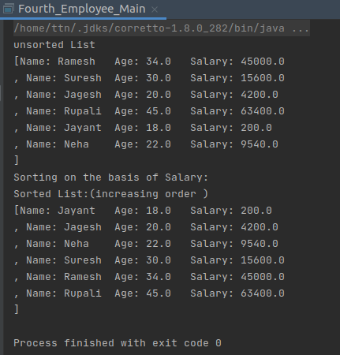

Q-5. Write a program to sort the Student objects based on Score , if the score are the same then sort on First Name . Class Student{ String Name; Double Score; Double Age.

**ScoreComparator.java**

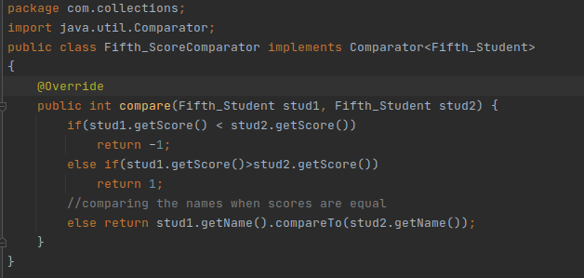

**Student.java:**

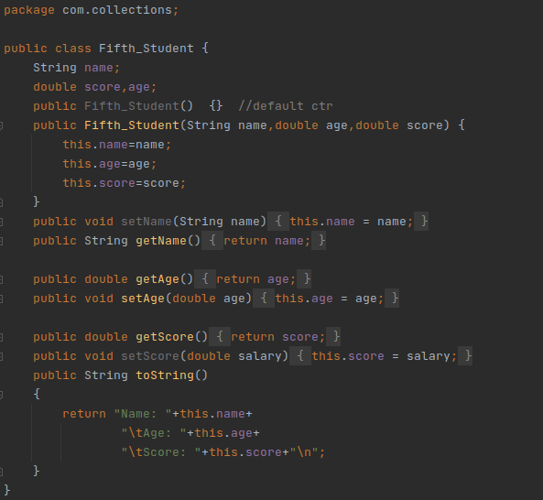

**StudentMain.java :**

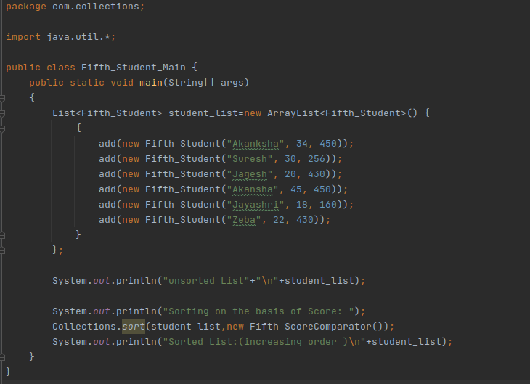

Output:

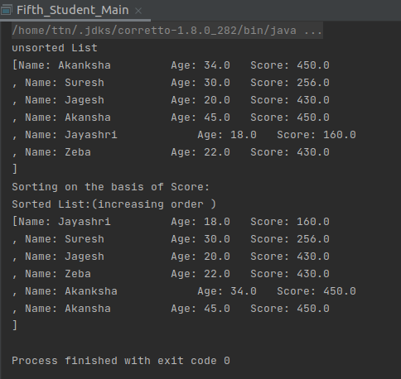

Q-6: Print the elements of an array in the decreasing frequency if 2 numbers have same frequency then print the one which came first.

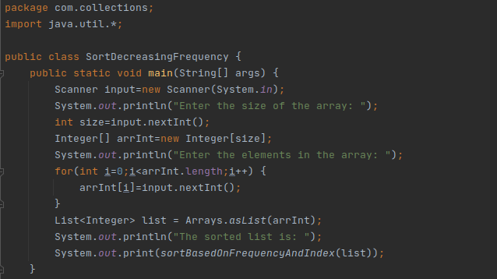

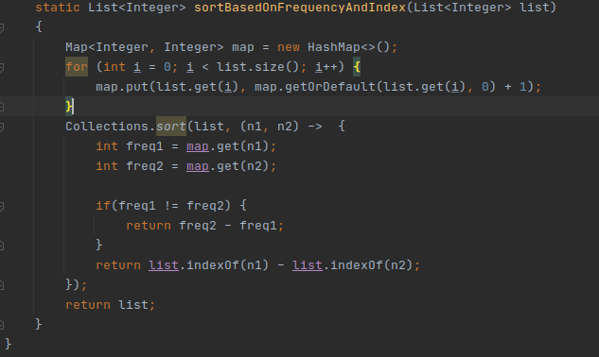

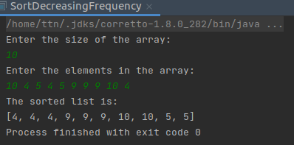

Q-7. Design a Data Structure SpecialStack that supports all the stack operations like push(), pop(), isEmpty(), isFull() and an additional operation getMin() which should return a minimum element from the SpecialStack. (Expected complexity ­ O(1))

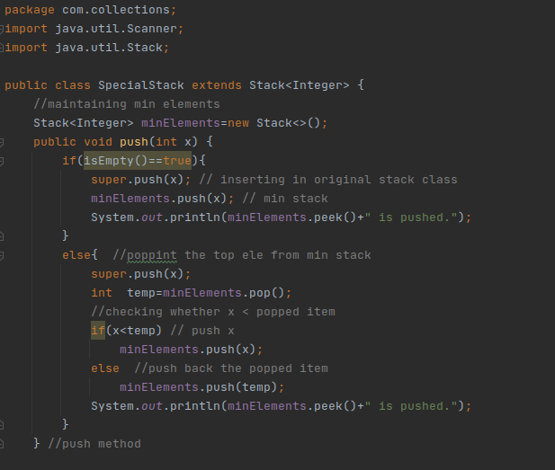

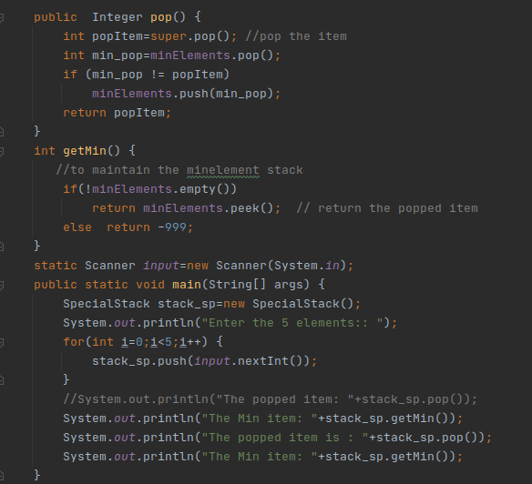



Output:

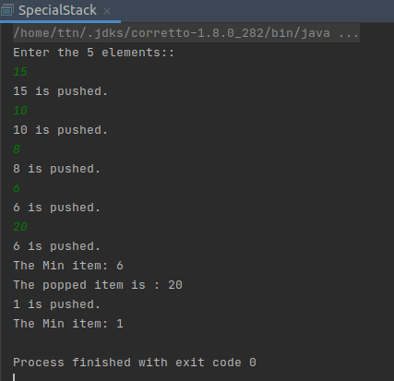

Q-8 Write a program to format the date as example "21-March-2016".

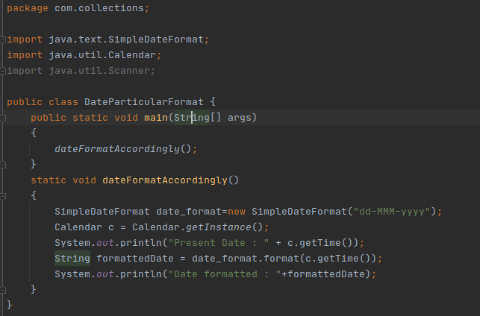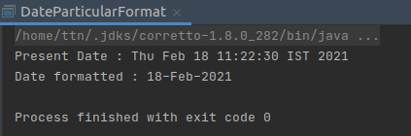

Q-9.Write a program to display times in different country format.

